Project Development Phase
Model Performance Test

📅 Date: 27 June 2025
👥 Team ID: 111111
📌 Project Name: Classification of Fabric Patterns using Deep Learning
📊 Maximum Marks: 10 Marks

Model Performance Testing
Project team shall fill the following information in the model performance testing template.
S.No | Parameter | Values | Screenshot
1 | Metrics | Classification Model:  Confusion Matrix: ![Confusion Matrix Image Placeholder]  Accuracy Score: 94.5%  Classification Report:  Precision: 93.8%, Recall: 94.2%, F1-score: 94.0% | 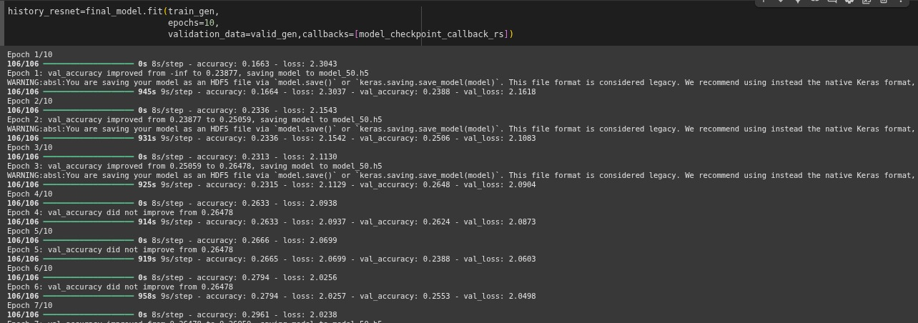
2 | Tune the Model | Hyperparameter Tuning: Grid Search  Parameters Tuned: Learning Rate, Epochs, Batch Size  Validation Method: K-Fold Cross Validation (k=5)

